

Forensics Report CA1

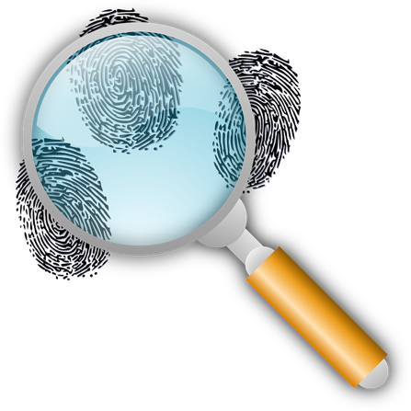

TU857

BSc in Computer Science Infrastructure

**Omair Duadu**

**C18322011**

School of Computer Science

TU Dublin – City Campus

**21/02/2022**

**Table of Contents**

*1.* *Case Introduction* 6

*2.* *Summary of the information* 7

*3.* *Forensic Tools and Techniques Used* 9

*4.* *Forensic Examination* 10

*5.* *Findings* 11

*6.* *Recommendations* 24

Declaration

I hereby declare that the work described in this dissertation is, except where otherwise stated, entirely my own work and has not been submitted as an exercise for a degree at this or any other university.

Signed:

____________Omair Duadu_____________

Omair Duadu

15/03/2022

**Case Information**

**Case Number:** 2022

**Offense:** Suspected Insider Trading

**Submitting Officer:** (Name/ID#)

**Victim:** Superake Inc

**Suspect:** Diana Prince

**Date/Time Seized:** 17th February 2022 @ 17:33

**Location of Seizure:** 123 fake Street, Dublin (Level 2, office 2-12)

|  |  |  |
| --- | --- | --- |
| **Description of Evidence** | | |
| **Item #** | **Quantity** | **Description of Item** (Model, Serial #, Condition, Marks, Scratches) |
| **2022-1** | 1 | TDK 16GB USB Flash Drive – TF10 USB 2.0 Flash Drive  Asset Tag:  Good condition, no external marks present.  Hardware Asset tag: 45378 |
|  |  |  |

|  |  |  |  |  |
| --- | --- | --- | --- | --- |
| **Chain of Custody** | | | | |
| **Item #** | **Date/Time** | **Released by** (Signature & ID#) | **Received by** (Signature & ID#) | **Comments/Location** |
| **2022-1** | Thursday 17/02/2022 @ 17:33 | Diana Prince | Security Manager | Diana Prince an Employee was found to have the drive while exiting the premises, sounding the alarm. The Security team followed procedure, isolating and securing the suspect and drive in the security room where the following occurred: reference pictures were taken of the drive next to a coin and in a safe which was locked by the security team manager, under supervision of the CTO and a member of the HR team |
| **2022-1** | Thursday 17/02/2022 @ 18:20 | Security Manager | CTO and HR member | They watched over the contents of the safe. |
| 2022-1 | Friday 18/02/2022 @ 13:20 | Security team manager | Miles Dyson -Systems manager | Miles took the drive to make a forensic image of the USB key. He has complete certification and equipment to complete this task. |
| 2022-1 | Wednesday 02/03/2022 @ 10:00 | Miles Dyson | Omair Duadu -Forensic Specialist | Received the USB key to perform a forensic analysis to extract and recover as much data as possible. |

**Examiners Details**

Omair Duadu – Forensic Examiner

|  |  |  |
| --- | --- | --- |
|  |  |  |
|  |  |  |

# *Case Introduction*

The purpose of this report is to provide the results of the forensic analysis which has been completed on behalf of the client Superfake Inc in relation to the USB Key. The relevant facts that are presented are unbiased and within the area of expertise and knowledge of the forensic specialist.

# *1.1 Summary of case and tasking*

On Thursday 17th February of 2022 @ 17:33 Diana prince passed through the scanner sounding an alarm. The security team proceeded with the plan for such a scenario. After following procedure, the USB Key was secured and placed under the supervision of the CTO and a member from human resources.

The data that was discovered/recovered was of a very sensitive nature and appears to have been confidential even among the company employees. This is a very dangerous situation as private data has been acquired and may have caused a breach of data.

The data recovered contains schematics of multiple models produced by the company for example Model_T_1000, Model_T_800, and many more models and schematics, a private email from Jon to Bruce was found with what appears confidential information. There were 2 encrypted files called AddressBook.xlsx and Blueprint.docx. Other miscellaneous files under a directory called Holiday was found.

# *1.2 Statement of Compliance*

I understand my duty as an expert witness to provide independent assistance by way of objective unbiased opinion in relation to matters within my expertise. I will inform all parties in the event that my opinion changes on any material issues.

# *Summary of the information*

Information Source:

TDK 16GB USB Flash Drive – TF10 USB 2.0 Flash Drive

Asset Tag:

Good condition, no external marks present.

Hardware Asset tag: 45378

We are required to make an image of the drive. This has been done using Autopsy to create an image of the drive and attempting to recover any data that was on the USB key at any point. Recovery of images using a hex editor in case they were corrupted was also essential.

The goal of this is to recover all of the data that we can to discover the extent of the security breach and any other factors that are involved in this incident. It is essential that all data is recovered on a best effort and ability basis so that it can be presented to the client in a satisfactory manner.

We are dealing with a USB key that was found on the person of Diana Prince on the 17th of February 2022 at 17:33.

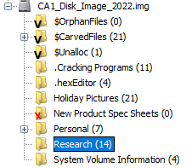

Figure 1

From the carved files you will find many images and dot apple files from the operating system. There are many blueprints, intranet portal of Superfake Inc, and images of desktop screenshots from Bruce Wayne's personal computer. Images of a confidential email to Bruce from Jon appear in many places in the USB key.

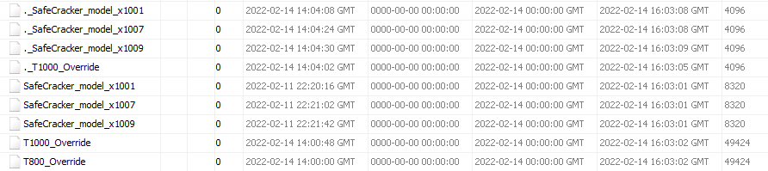

Figure 2

In .Cracking programs directory there 9 files in total and each files either has override or safecracker in the name. I was unable to find contents off these files. From an objective point of view these files making contain concerning data for Superfake Inc.

In .hexEditor only contained two files one of which held a simple c language program, the other files contents are unknown.

The Holidays Pictures directory contained 19 files many of which were carved images and others seem to be innocent holiday pictures. The carved images contained blueprints, intranet portal images, and other similar sensitive data.

The New Product Spec Sheets directory was carved and found to be empty. It is unknown if it was carved unsuccessfully, or it was truly empty.

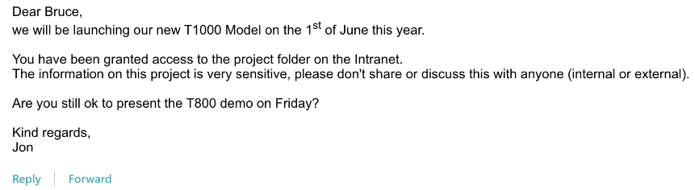

Figure 3

The Personal directory has 5 files all of them appear to be a variation of Email. This may be intentional, or an error may have occurred when trying to recover the USB key. The all hold the email from Jon to Bruce.

The Research directory has 12 files, 8 of them are images of safe. 4 of them are the same email from Jon to Bruce.

The System Volume Information has 2 files, which are unrecognized and are likely to be general system files.

# *Forensic Tools and Techniques Used*

***Autopsy v 4.19.3***

Autopsy a digital forensics platform and a graphical interface to the sleuth kit and other digital forensics tools. It is used by law enforcement military and corporate examiners to investigate what happened on a computer. You can even use it to recover photos from your camera's memory card. Some of its features that it is capable of is timeline analysis, hash filtering, keyword search, web artifacts, data carving, multimedia extraction, and indicators of compromise. Many of these were used in our analysis of the drive.

***HxD v 2.5***

HxD is a carefully designed and fast hex editor which, additionally to raw disk editing and modifying of main memory (RAM), handles files of any size. The easy to use interface offers features such as searching and replacing, exporting, checksums/digests, insertion of byte patterns, a file shredder, concatenation or splitting of files, statistics and much more.

It was used for the editing of image files(jpg) that may have been corrupted during the recovery process or possibly even intentionally altered.

***FTK Imager v 4.7***

FTK Imager is a data preview and imaging tool that lets you quickly assess electronic evidence to determine if further analysis with a forensic tool such as FTL is warranted. Create forensic images of local hard drives, CDs and DVDs, thumb drives or other USB devices, entire folders, or individual files from various places within the media.

This was used to create a forensic image of the USB key that can be loaded into autopsy for analysis and any potential data recovery.

***Microsoft Word 2019 v 16.0.14931.20120***

Microsoft Word is a word processing software developed by Microsoft. It is used to record and document the findings throughout the forensic investigation.

***Windows 10 Home v 21H2***

Windows 10 is a Microsoft operating system for personal computers, tablets, embedded devices and internet of things devices. Microsoft released Windows 10 in July 2015 as a follow-up to [Windows 8](https://www.techtarget.com/searchenterprisedesktop/definition/Windows-8). The company has said it will update Windows 10 continuously, rather than release a new, full-fledged operating system as a successor.

***EaseUS.com***

EaseUS RepairVideo, which is a very powerful and free online MP4 video repairtool.

Used this tool to repair and recover the error.mov

# *Forensic Examination*

Detailed description of the process followed as part of your forensic examination.

This should be in chronological order.

(Maybe each task should get its own sub-section)

The process followed should be documented in detail (eg. Everything we did to recover the data)

The first step taken was to create a new case in autopsy for this forensic examination. After loading in the image, the total image size was 1.00068 gigabytes. There were 10 total directories as can seen below.

While analysing the folders I made a note of all the files and images that were found and displayed them in Section 5 of the report, listing the findings in order of folder and importance level. The importance of the data was judged in an unbiased manner from an objective point of view for the sanctity of this report.

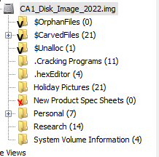

Figure 4

The first thing to do for the investigation was to have a quick scan of the contents of all these directories. This was done to check which of these files may need more work and attention. The results of the Carved Files folder was very important as it may show what the data may have been on the USB key but then deleted to hide them again. As expected many of the files seem to be of a high level of sensitivity.

After the carved files directory I continued through the other folders in a descending order making a note of which files may have been corrupted, this was mainly for image jpg files. This is important as I was able to recover some corrupted/hidden images. This is called steganography and a few of these hidden images contained more blueprints. All of this was recorded in section 5 below.

The Holiday Pictures, Personal, and Research folders contain the majority of the data. All the sensitive images in these folders are recorded.

# *Findings*

Many of these files contain highly confidential data, that is meant on a need to know basis. The data being carried on the drive is a security risk and it is concerning that an employee was about to leave the company premises with it.

# *5.1 Home/Main Directory*

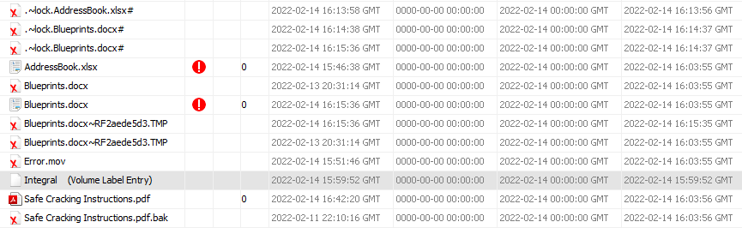

Figure 5

The first findings were in the home directory of the USB key image. There were 9 folders and 12 files. Two files namely AddressBook.xlsx and Blueprints.docx were found on the drive with encryption. We have been unable to decrypt it and find their contents. We would recommend a specialist or if the true owners of those files are available and known to decrypt them. If this is not an option, then there are recovery tools that can be downloaded or used online which require payment.

Another possibility is that someone at Superfake Inc may already know the password. The next step to take is up to the client to decide upon, not included in the forensic analysis.

The other 6 files with similar names to the two encrypted files are either system files or may be corrupted beyond our expertise.

Error.mov is the next find and it was also recovered by autopsy, however it was not recovered properly and could not be played. Using easeUS RepairVideo I was able to repair the video successfully and make its contents available. The video is a white background with a mouse pointer with no sound or movement. There may be steganography used to hide information in the frames whoever this requires a specialist.

Safe Cracking Instructions pdf(FIGURE 6) has been safely recovered and is accessible. The contents of it seem to be of high value relating to the Super Safe T-1000.

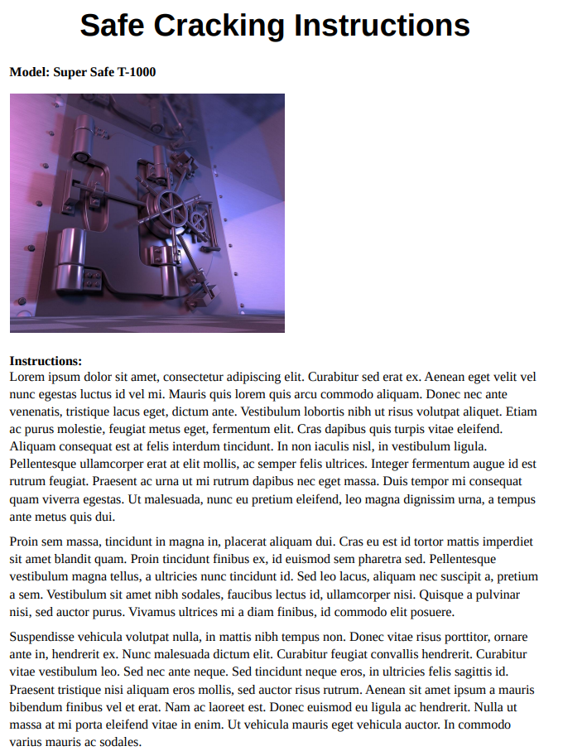

Figure 6

The final file Safe Cracking Instructions.pdf.bak contains a image(FIGURE 7)of an email correspondence from Jon to Bruce. It is highly confidential email which is not to be shared with anyone in internal or external, sent by Jon to Bruce. It is suspect that Diana was carrying sensitive data which she may not have permissions for. Note this email was a deleted file.

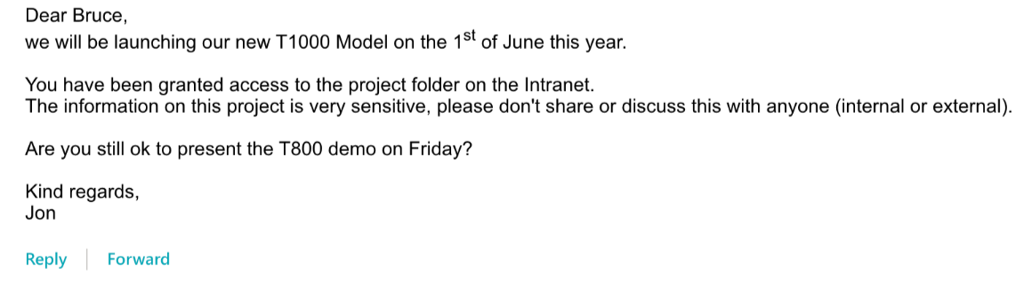

Figure 7

# *5.2 .Cracking Programs*

The first real directory is called Cracking Programs(Figure 8). It contains what appear to be computer programs that are codded in the C language. The true contents of the files cannot be deciphered in this investigation however the naming scheme adopted is of concern to the client.



Figure 8

# *5.3 .hexEditor*

This folder(FIGURE 9) just contains 2 files of a simple harmless c program and a system and config file.



Figure 9

# *5.4 Holiday Pictures*

This Folder holds a total of 19 files most of which were carved. The first 6 of the files are inaccessible and most likely system files. 4 images are of nature and could potentially be from a holiday according to the folder name. The rest of the files are all of company property and are highly confidential

All the below images were accessed and created on 14-02-2022 and modified on 16:48:50GMT.



Figure 10

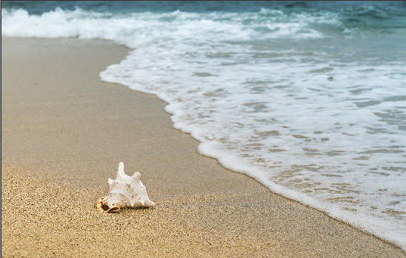

Figure 11



Figure 12



Figure 13

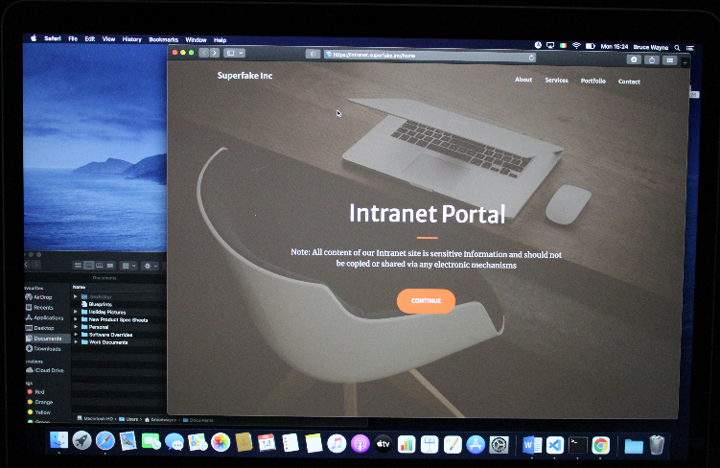

Figure 14

The above FIGURE 14 is a deleted image that seems to be taken by Bruce Wayne’s desktop of the company’s intranet portal. The intranet portal holds confidential information which is clearly visible to the offender as it is written across the page.

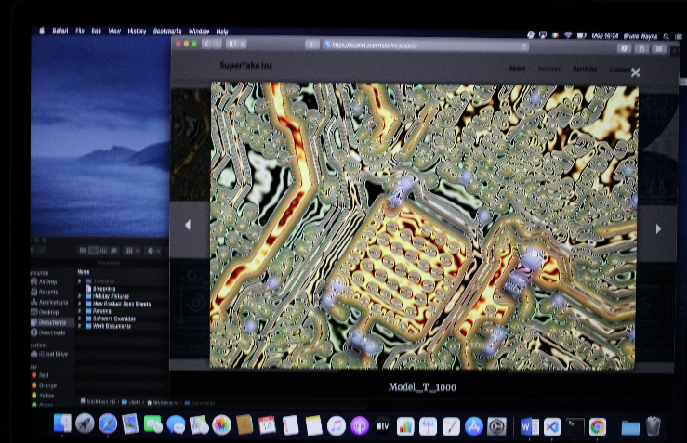

Figure 15

The above FIGURE 15 displays an image of the Model_T_1000 and its specs. These were previously mentioned in an email as highly confidential. The image is a screenshot of the Bruce Wayne’s desktop with the internal portal displaying the Mode_T_1000.

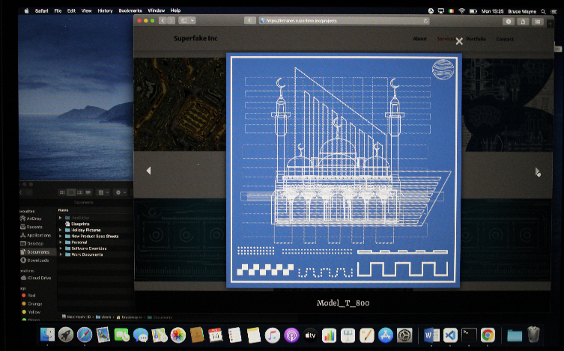

Figure 16

The above FIGURE 16 is the model Model_T_800 which is on the internal portal. Therefore the suspect was carrying confidential data. This was once again accessed through Bruce Wayne’s desktop.

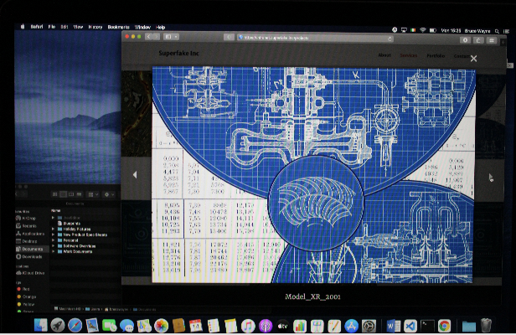

Figure 17

The above FIGURE 17 is shows Model_XR_2DD2 was taken from Bruce Wayne’s desktop through the internal portal. This is another violation of security.

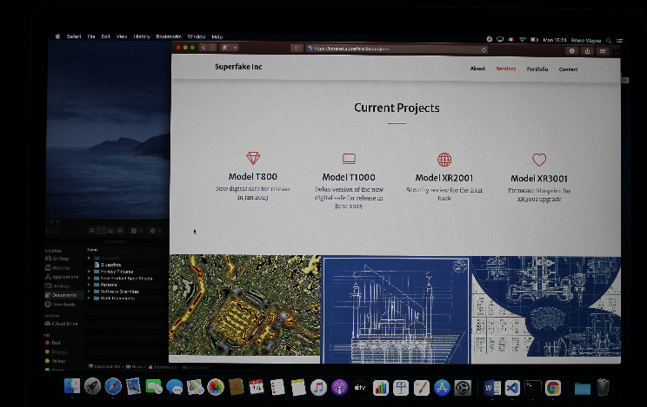

Figure 18

The FIGURE 18 above is of the confidential internal portal, multiple models and blueprints can be seen. This was once again accessed through Bruce Wayne’s desktop.

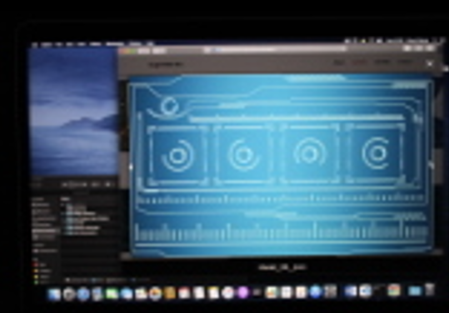

Figure 19

This file FIGURE 19 was recovered from photo_7.jpg. It seems to have been corrupted, as a result the image is blurry, and no writing is eligible. The image seems to come from the intranet portal however, so someone with access to the portal may be able to recognise it.

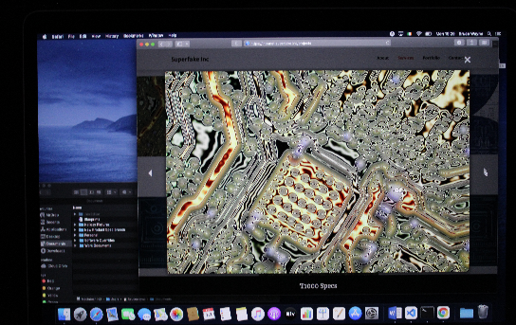

Figure 20

The FIGURE 20 above is of the confidential internal portal, model T1000 Specs can be seen according to the image. This was once again accessed through Bruce Wayne’s desktop.

# *5.5 Research*

The below files(FIGURES 21 to 27) were all recovered from Research folder. Each of these images depict different safes and their method of operation. It would be advised that any safes at the Superfake Inc HQ or the work they are involved in as they may find similarities with them.

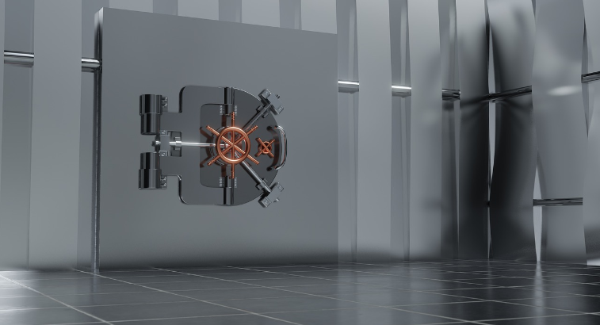

Figure 21

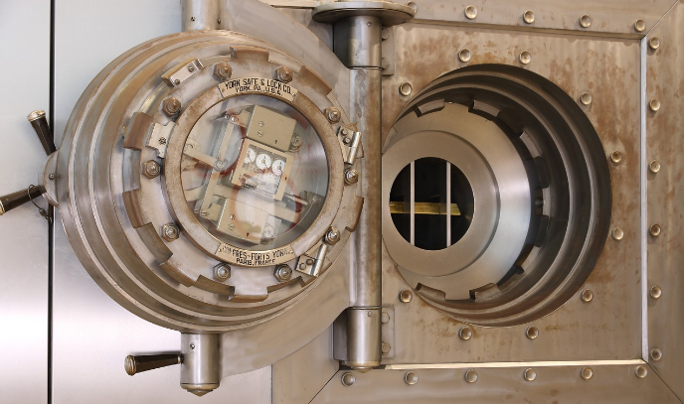

Figure 22

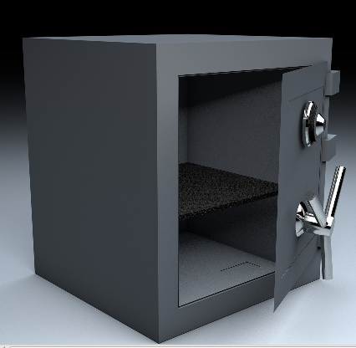

Figure 23

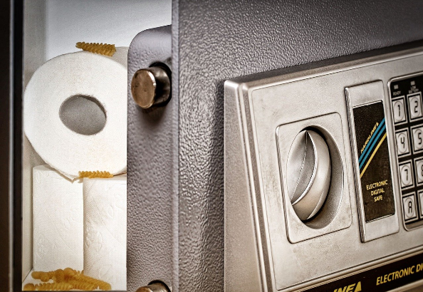

Figure 24

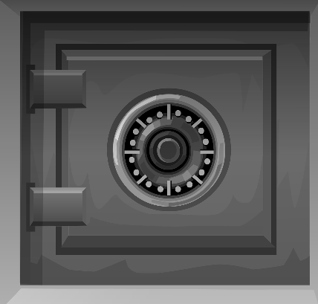

Figure 25

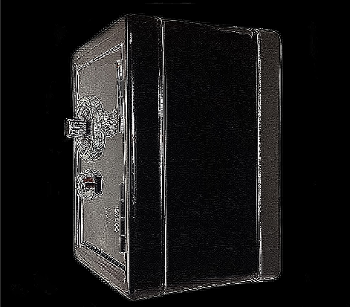

Figure 26

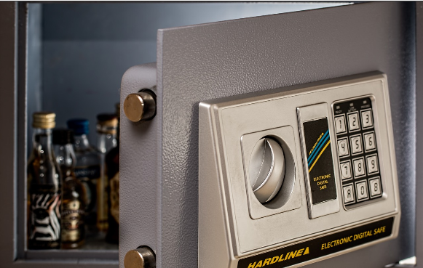

Figure 27

In addition to the images of the safes 4 identical copies of the email correspondence in FIGURE 28 appears in 4 files in this directory. This may be an accident from Autopsy, FTK Imager or it truly appeared in this folder 4 times.

# *5.6 New Product Spec Sheets*

This Folder was found to be empty and contain nothing however the name of the folder may be of concern to the intention behind creating it.

# *5.7 Personal*

This folder contains 5 files 3 of which are either corrupted or system/config files. They contain the same correspondence from Jon to Bruce. This may be the true origin of the email and an accident may have caused it to appear in multiple other places.

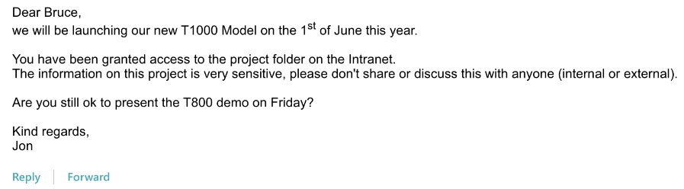

Figure 28

# *5.8 System Volume Information*

Contains 2 files which are system/config files.

# *Recommendations*

Many of these files contain highly confidential data, that is meant on a need-to-know basis. The data being carried on the drive is a security risk and it is concerning that an employee was about to leave the company premises with it.

It would be very prudent of Superfake Inc to find out who had access to the drive? Who made it? Why they have access to Bruce Wayne’s desktop? And to revaluate their security policy and procedure.

The 2 encrypted files namely AddressBook.xlsx and Blueprints.docx were not able to be accessed as they are password protected. It would be advised that Superfake Inc invest in opening these files as they may hold more sensitive data, and it is essential to know the extent of the data breach. They may approach specialists, or use specialised software for this process that can be found online.

The contents of .Cracking Programs are also of high suspicion, it is advised that Superfake Inc invest into discovering the capabilities of the programs in this folder as they may concern the clients business operations and security.

The Safe Cracking Instructions pdf(FIGURE 6) is also of sensitivity as it appears to contain data that can affect Superfake Inc’s business operations and security directly if it can achieve what is advertised.

The error.mov is also not a closed case for the time being as there may be more data hidden in it using steganography.

The email correspondence may have also been leaked from Bruce Wayne’s desktop as it appears that the rest of the images have also come from there, however this is not certain and requires further investigation.

Overall it is advised that Superfake Inc revaluate their security procedure and as soon as possible.

The true extent of the data breach is still unknown as some files as stated previously have not been fully accessed or assessed.